NDVI-based livestock insurance for Borana zone
This document describes the design of NDVI-based livestock insurance for Borana zone, outlines the key contract design decisions and proposes some recommendations from the Cornell-ILRI research team on the contract to be commercialized, hopefully starting January 2012.
Contract summary: Like the IBLI Marsabit contract in Kenya, the IBLI Borana contract will use a function of the satellite-based, remotely-sensed normalized differenced vegetation index (NDVI) to trigger insurance payout. The contract is an annual contract combining two coverage seasons: long rains-long dry (LRLD, March-September) and short rains-short dry (SRSD, October-February). The contract will be available at Woreda level for 8 of the pastoral Woredas in the Borana zone. But unlike the Marsabit contract that offers indemnity payments based on statistical predictions of livestock mortality rates as a function of NDVI, IBLI Borana will be triggered directly by the cumulative deviation of NDVI from the thirty-year average level for the coverage season as mapped linearly into loss coverage.
This IBLI Borana contract shows considerable promise. First, the plots of cumulative deviation of NDVI from normal of each and every Woreda accurately reflect the key historical drought years in each location well. The cumulative deviation of NDVI from normal drops far below zero for the key drought years identified in focus group discussions the Cornell-ILRI team conducted in the targeted area. This gives us confidence that the proposed contract would have correctly triggered payout during historical drought years based on these observed cumulative deviation of NDVI from normal variables. Second, the contract can be easily scalable given availability of NDVI data. It would be relatively quick, easy and inexpensive to replicate this design in other pastoral areas of Ethiopia or elsewhere. Third, the contract may also prove easier to educate clients about than the IBLI Marsabit product. By making indemnity payout an explicit, linear function of cumulative deviation of NDVI from normal, this contract would provide clients with a direct mapping of NDVI (observed in near real time) to potential indemnity payout, eliminating the “black box” element of the statistical herd mortality prediction that in some cases created confusion for clients in Marsabit. Moreover, purchasers and the underwriter can easily track the evolution of seasonal payout over time as NDVI data become available.
The Normalized Difference Vegetation Index (NDVI): is a satellite derived indicator of
the amount and vigor of vegetation present on the land. The magnitude of NDVI is related to the level of photosynthetic activity in the observed vegetation. Images of NDVI are sometimes referred to as "greenness maps" since they represent the vegetative vigor of plants. In general, high values of NDVI indicate greater forage available on the rangelands, which also signals greater water availability and thus more hospitable conditions for livestock.
- There are two sources of NDVI data used in the contract design and pricing.
- MODIS NDVI from MODerate-resolution Imaging Spectroradiometer on board the United States’ National Aeronautics and Space Administration (NASA)'s Terra satellite. The data are available in near real time every 16 days from April 2000 to present at the resolution of 250×250m. MODIS NDVI data will be used to construct the index that triggers IBLI payout.
- AVHRR NDVI produced from the Advanced Very High Resolution Radiometer (AVHRR) sensor carried aboard the United States’ National Oceanic and Atmospheric Administration (NOAA)’s polar-orbiting weather satellites. The AVHRR data are available in near real time every 10 days at the resolution of 8.0× 8.0 km from 1982 to early 2010 when the sensor suffered degradation and stopped producing further data. We rescaled AVHRR NDVI data based on the overlapping 2001-2010 period and used the rescaled AVHRR series to complement MODIS NDVI during the earlier 1982-2000 period. The combination of MODIS and AVHRR series allows us to use the longer 1982-2011 time series for proper actuarial pricing.
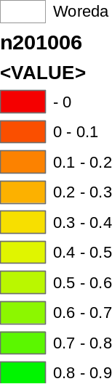
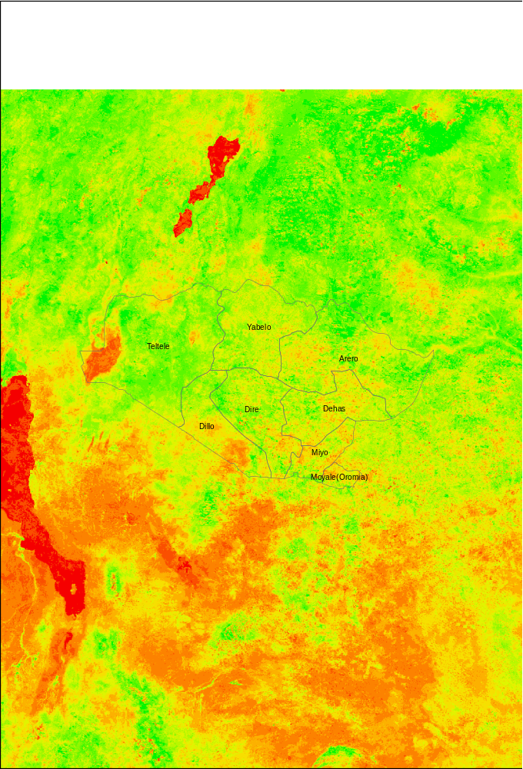

MODIS NDVI in 8 Woredas of Borana Zone, Ethiopia: March, 2010
- In order to take into account the differences in weather’s impact on vegetation, given geographic attributes and resources (soil, vegetation type and topography) and local populations’ adaptation to local climatic and physical geographic conditions, we standardize NDVI based on pixel-and-time-specific mean and variance. The standardized NDVI, which we label ZNDVI, for any pixel i of 16-day period f in year t can thus be written as
$${ZNDVI}_{ift}=\frac{{NDVI}_{ift}-E_{if}({NDVI}_{if})}{σ_{if}({NDVI}_{if})}$$
where ${NDVI}_{ift}$ is the image of NDVI for pixel i for 16-day period f of year t, $E_{if}({NDVI}_{if})$ is the long-term mean of NDVI values for 16-day period f of pixel i taken over 2000-2011 for MODIS NDVI (1982-2010 for AVHRR NDVI) and $σ_{if}({NDVI}_{if})$ is the long-term standard deviation of NDVI values for 16-day period f of pixel i taken over 2000-2011 for MODIS NDVI (1982-2010 for AVHRR NDVI). Positive (negative) ${ZNDVI}_{ift}$ represents relatively better (worse) vegetation conditions relative to the long-term mean of the specific pixel and period driven. ${ZNDVI}_{ift}$ for each pixel i are first extracted for each specific time. Woreda-level ${ZNDVI}_{wft}$ for each period can then be constructed by taking the average values of ${ZNDVI}_{ift}$ of all pixels that fall within each Woreda boundary.
- To reasonably capture the cumulative impact of weather and associated (e.g., stocking rate) changes over the course of a season, we take into account the cumulative path of ZNDVI by accumulating ZNDVI from the beginning until the end of the coverage season, where s = LRLD (March-September) or SRSD (October-February). The cumulative ZNDVI realized at the end of each coverage season, Czndvi, represents cumulative deviation of vegetation conditions from normal over the course of the coverage period. The Czndvi index will be used to trigger insurance payout at the end of each season.

Contract terms
- Czndvi to be realized at the end of each coverage season is the cumulative ZNDVI starting from the beginning until the end of coverage season t for each Woreda w, where
For LRLD season (7 months, 13 16-day periods): ${Czndvi}_{w,LRLD}=\sum_{f=Mar, f5}^{Sept, f17}{{ZNDVI}_{wft}}$
For SRSD season (5 months, 10 16-day periods): ${Czndvi}_{w,SRSD}=\sum_{f=Oct, f18}^{Feb, f4}{{ZNDVI}_{wft}}$
Sample plots of a notional annual contract with LRLD and SRSD windows for 4 Woredas are shown below. The Czndvi_{w,s} level at the end of each season s and for each Woreda w determines indemnity payout, as explained below.

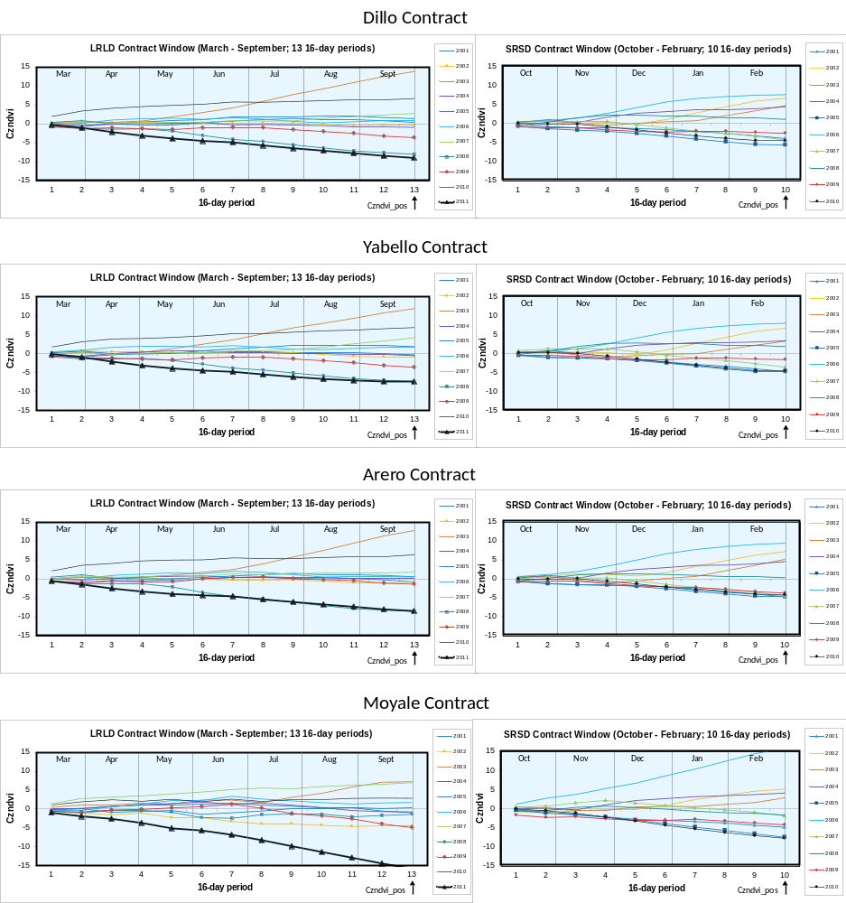

- Temporal coverage: Each contract covers 1 year with 2 different seasons: LRLD (covering 7 months from Mar-Sept) and SRSD (covering 5 months from Oct-Feb).
- Spatial coverage: Each contract is specific at the Woreda level (w). The client can choose the coverage Woreda based on where their livestock commonly locate.
- Maximum payout rate (% of total insured livestock) is the maximum percentage of total insured livestock value that can be paid out by the insurance contract. We recommend setting this at 50% for all Woredas and seasons. Note that 50% is roughly equal to maximum area-averaged livestock losses associated with severe droughts observed in the household-level loss data.
- Minimum triggered payout rate (% of total insured livestock) is the minimum percentage of total livestock value that will be paid out by the insurance company if contract is triggered (i.e., if Czndvi is below the strike level). We recommend setting this equal to the seasonal premium rate (50% of annual premium rate) so that when the contract triggers, clients receive, at a minimum, reimbursement of their premium for that season.
- Exit: is the level of Czndvi, below which the maximum payout rate will be made. This caps underwriter exposure.We recommend setting this at the season-and-Woreda-specific minimum level of Czndvi observed in the 1982-2011 data.
- Strike level is the level of Czndvi below which the contract triggers indemnity payout. The current contract is designed and priced for 5 different strike levels with different historical payout frequencies. These five strikes are constructed based on observed historical distributions of Czndvi for each Woreda and season. These 5 strike levels are
- Percentile 10 ( at payout frequency of 1-in-10 season or 1-in-5 year with 2 seasons)
- Percentile 15 ( at payout frequency of 1-in-7 season or 1-in-3.5 year with 2 seasons)
- Percentile 20 ( at payout frequency of 1-in-5 season or 1-in-2.5 year with 2 seasons)
- Percentile 25 ( at payout frequency of 1-in-4 season or 1-in-2 year with 2 seasons)
- Percentile 30 ( at payout frequency of 1-in-3 season or 1-in-1.5 year with 2 seasons)
We recommend offering menu of strike levels, including at least Percentile 10 and 15 (with different premiums for each), from which clients can choose based on their financial liquidity and appetite for risk.
- Sum assured: is the total value of livestock a client chooses to insure. This can be calculated by multiplying the total number of aggregate unit of livestock one chooses to insure (TLU) by price per aggregate unit (P_{TLU}). A decision needs to be made if P_{TLU} should be fixed, as is the case in the IBLI Marsabit contract, (and fixed at what price that would be most appropriate for Borana zone) or if the insurer will allow the client to name his/her chosen valuation for amount of livestock they which to insure. Since the premium amount paid is a function of the livestock value assured, this flexibility may afford clients more control over the design of their personalized product without affecting underwriter exposure.
- Payout function: The seasonal payout function will be conditional on Czndvi, Strike, Exit, Maximum payout rate, Minimum triggered payout rate, TLU and P_{TLU}.
General form of seasonal payoff function can be written as:
(i) $Seasonal Payout=\% of maximum payout rate×Max payout rate×TLU×P_{TLU}$

Hence, without minimum triggered payout:
(ii) $Seasonal s Payout= \left(\frac{{Strike}_{s}-{Czndvi}_{s}}{{Strike}_{s}-{Exit}_{s}}\right)×Max payout rate×TLU×P_{TLU}$

With minimum triggered payout:
(iii) $Season s Payout=Max\left[\left(\frac{{Strike}_{s}-{Czndvi}_{s}}{{Strike}_{s}-{Exit}_{s}}\right)×Max payout rate, Min payout rate\right]$
$$×TLU×P_{TLU}$$
We can plot the seasonal payout rate (% of sum assured) based on contract terms chosen by the underwriter, which is simply equation (iii) divided by the sum assured ($TLU×P_{TLU}$) – which are client choices – as:
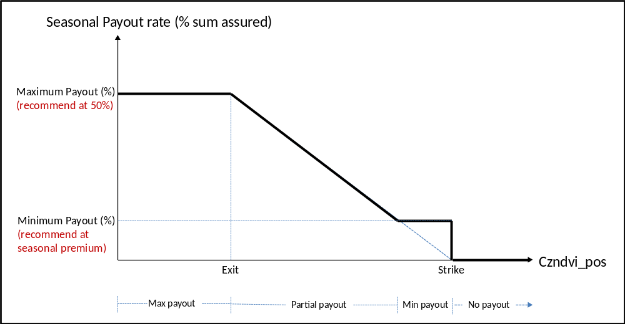

Total annual payout with two seasonal payouts (LRLD and SRSD) can be written as
(iv)$Annual Payout=\sum_{s=LRLD,SRSD}{Max\left[\left(\frac{{Strike}_{s}-{Czndvi}_{s}}{{Strike}_{s}-{Exit}_{s}}\right)×Max payout rate, Min payout rate\right]}$
$$×TLU×P_{TLU}$$
- Actuarial fair premium rate is calculated using burn rate approach. That is the annual premium rate estimated at the average of annual payout rates based on available 1982-2011 Czndvi data. The annual payout rates are constructed by combining two revolving seasonal payout rates together. Once contract terms are finalized, we can further explore the pricing using Monte Carlo simulations.

